**Name: Gaurang Vaghela**

**Rollno: TEAD-22561**

**DS (SL-III)**

**Practical 5**

**Code:**

**1. Import libraries, load and process ‘Social_Network_Ads.csv’ dataset.**

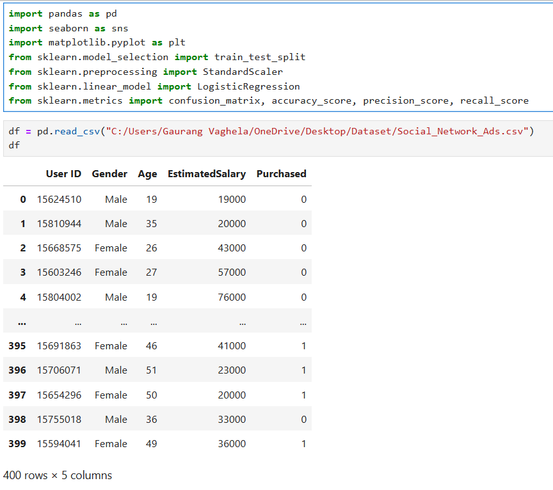

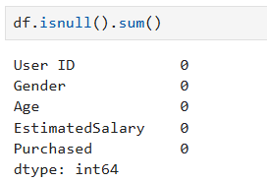

**2. Implement logistic regression using Python/R to perform classification on  
 Social_Network_Ads.csv dataset.**

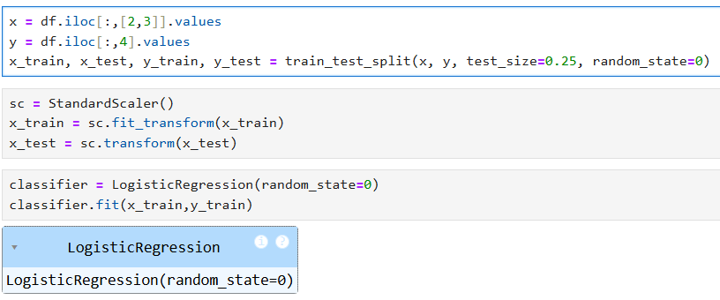

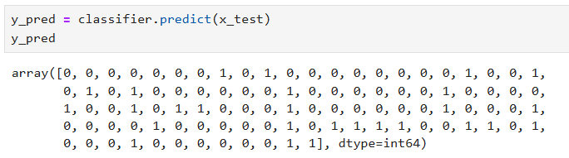

**3. Compute Confusion matrix to find TP, FP, TN, FN, Accuracy, Error rate, Precision, Recall**

**on the given dataset.**

